DIABETIC PREDICTION

**DATASET:**

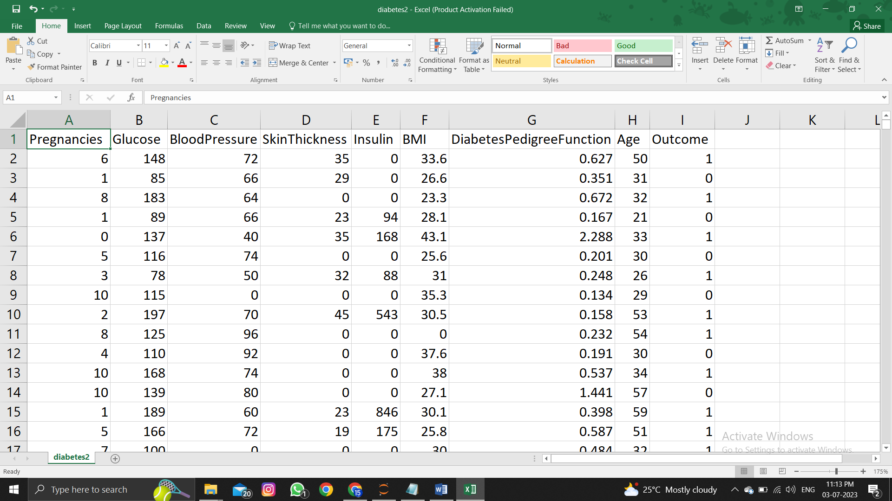

**Column fields are:**

* Pregnancies
* Glucose
* BloodPressure
* SkinThickness
* Insulin
* BMI
* DiabetesPedigreeFunction
* Age
* Outcome

**ML TECHNIQUES USED:**

* **Random Forest**
* **Neural Network**
* **SVM**
* **Gradient Boosting**

**CODING:**

**The test size parameter is set to 0.2, which means that 20% of the data will be used for testing, and the remaining 80% will be used for training.**

import pandas as pd

from sklearn.model_selection import train_test_split

from sklearn.ensemble import RandomForestClassifier, GradientBoostingClassifier

from sklearn.svm import SVC

from sklearn.metrics import accuracy_score, precision_score, recall_score, f1_score

import time

from tabulate import tabulate

# Load the dataset

data = pd.read_csv('your_dataset.csv') # Replace 'your_dataset.csv' with the actual dataset filename

# Split the data into features (X) and target (y)

X = data.drop('Outcome', axis=1)

y = data['Outcome']

# Split the data into training and testing sets

X_train, X_test, y_train, y_test = train_test_split(X, y, test_size=0.2, random_state=42)

# Random Forest

rf_classifier = RandomForestClassifier()

start_time = time.time()

rf_classifier.fit(X_train, y_train)

training_speed_rf = time.time() - start_time

start_time = time.time()

rf_predictions = rf_classifier.predict(X_test)

prediction_speed_rf = time.time() - start_time

rf_accuracy = accuracy_score(y_test, rf_predictions)

rf_precision = precision_score(y_test, rf_predictions)

rf_recall = recall_score(y_test, rf_predictions)

rf_f1 = f1_score(y_test, rf_predictions)

# Neural Network (using scikit-learn MLPClassifier)

from sklearn.neural_network import MLPClassifier

nn_classifier = MLPClassifier(hidden_layer_sizes=(64, 64), activation='relu', solver='adam')

start_time = time.time()

nn_classifier.fit(X_train, y_train)

training_speed_nn = time.time() - start_time

start_time = time.time()

nn_predictions = nn_classifier.predict(X_test)

prediction_speed_nn = time.time() - start_time

nn_accuracy = accuracy_score(y_test, nn_predictions)

nn_precision = precision_score(y_test, nn_predictions)

nn_recall = recall_score(y_test, nn_predictions)

nn_f1 = f1_score(y_test, nn_predictions)

# SVM

svm_classifier = SVC()

start_time = time.time()

svm_classifier.fit(X_train, y_train)

training_speed_svm = time.time() - start_time

start_time = time.time()

svm_predictions = svm_classifier.predict(X_test)

prediction_speed_svm = time.time() - start_time

svm_accuracy = accuracy_score(y_test, svm_predictions)

svm_precision = precision_score(y_test, svm_predictions)

svm_recall = recall_score(y_test, svm_predictions)

svm_f1 = f1_score(y_test, svm_predictions)

# Gradient Boosting

gb_classifier = GradientBoostingClassifier()

start_time = time.time()

gb_classifier.fit(X_train, y_train)

training_speed_gb = time.time() - start_time

start_time = time.time()

gb_predictions = gb_classifier.predict(X_test)

prediction_speed_gb = time.time() - start_time

gb_accuracy = accuracy_score(y_test, gb_predictions)

gb_precision = precision_score(y_test, gb_predictions)

gb_recall = recall_score(y_test, gb_predictions)

gb_f1 = f1_score(y_test, gb_predictions)

# Create a comparison table

comparison_table = pd.DataFrame({

'Technique': ['Random Forest', 'Neural Network', 'SVM', 'Gradient Boosting'],

'Accuracy': [rf_accuracy, nn_accuracy, svm_accuracy, gb_accuracy],

'Precision': [rf_precision, nn_precision, svm_precision, gb_precision],

'Recall': [rf_recall, nn_recall, svm_recall, gb_recall],

'F1 Score': [rf_f1, nn_f1, svm_f1, gb_f1],

'Training Speed (s)': [training_speed_rf, training_speed_nn, training_speed_svm, training_speed_gb],

'Prediction Speed (s)': [prediction_speed_rf, prediction_speed_nn, prediction_speed_svm, prediction_speed_gb]

})

# Print the comparison table in table format

table_str = tabulate(comparison_table, headers='keys', tablefmt='psql')

print(table_str)

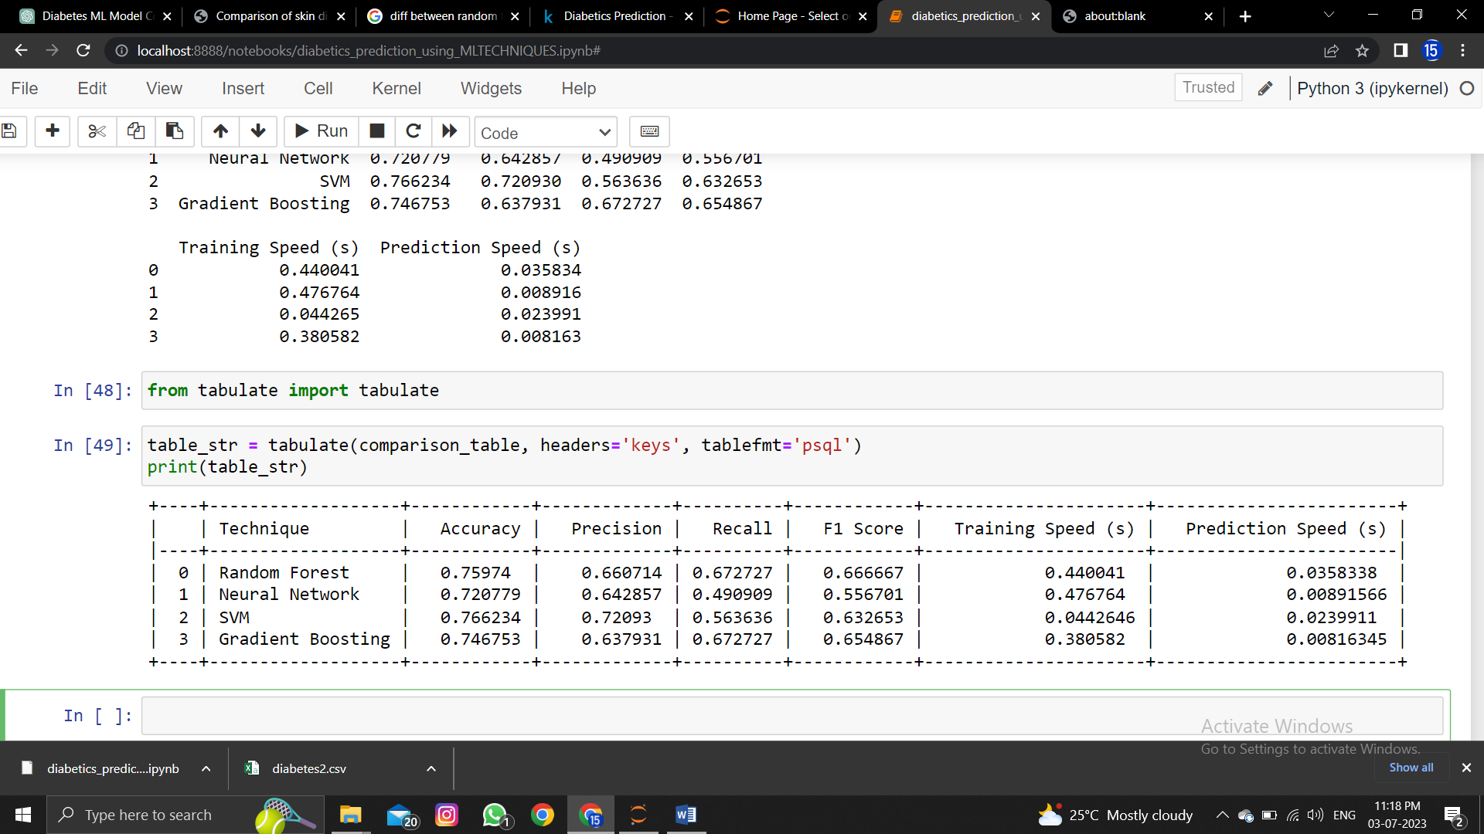**OUTPUT:**

**CONCLUSION:**

**Based on the results provided in the comparison table, we can assess the performance of each ML technique:**

**1. Random Forest:** It achieved an accuracy of 0.759740, precision of 0.660714, recall of 0.672727, and F1 score of 0.666667. The training speed was 0.440041 seconds, and the prediction speed was 0.035834 seconds.

**2. Neural Network**: It achieved an accuracy of 0.720779, precision of 0.642857, recall of 0.490909, and F1 score of 0.556701. The training speed was 0.476764 seconds, and the prediction speed was 0.008916 seconds**.**

**3. SVM:** It achieved an accuracy of 0.766234, precision of 0.720930, recall of 0.563636, and F1 score of 0.632653. The training speed was 0.044265 seconds, and the prediction speed was 0.023991 seconds.

**4. Gradient Boosting:** It achieved an accuracy of 0.746753, precision of 0.637931, recall of 0.672727, and F1 score of 0.654867. The training speed was 0.380582 seconds, and the prediction speed was 0.008163 seconds.

**To determine the best ML technique, you need to consider the specific requirements and objectives of your problem.**

**-** If **accuracy** is the most important metric, **SVM** achieved the highest accuracy (0.766234).

**-** If **precision** is crucial for your problem**, SVM** achieved the highest precision (0.720930).

**-** If recall is a **priority, Random Forest** achieved the highest recall (0.672727).

**Based on these factors, you can make an informed decision on which ML technique is best suited for your specific needs and requirements.**